**Market Basket Analysis & Store Optimization**

## Module: SQL Analysis

## Business Simulation Context

“SmartMart” is a **mid-size supermarket chain with 40+ outlets across metro cities**. Recently, the management has observed:

* While **sales have increased**, **profit margins are declining**.
* Popular products **run out of stock too quickly**.
* Some products are **never bought together**, leading to **poor shelf placement and unnecessary waste**.

To address these challenges, SmartMart has launched an initiative to **optimize store layout and promotions using Market Basket Analysis.** As part of the **Retail Data Strategy Team**, our group is responsible for delivering **data-driven, actionable insights using SQL**.

## Project Objectives

Using SQL, we aim to:

* **Identify products that are frequently bought together** to improve store layout and bundling.
* Help **reposition and bundle products** for a better customer experience and higher sales.
* **Optimize shelf space and stock placement** to reduce waste and stockouts.
* Recommend **pricing and promotion strategies using association rules** to improve profit margins.

## Tools & Technologies Used

**SQL (MySQL):** For querying and analyzing transactional sales and basket data to extract actionable insights.

**Dataset:** **market_basket_data** and **transactions** tables provided by SmartMart for analysis.

SQL Queries for Market Basket Analysis

## Goal of SQL Queries

To identify:

* **Top-selling products** driving sales but possibly reducing margins.
* **Frequently purchased product pairs** for bundling and shelf optimization.
* **Sales seasonality and day-of-week trends** to align promotions.
* **Basket size patterns** for upselling opportunities.

**SQL Queries Executed**1) SELECT itemDescription, COUNT(*) AS freq

FROM market_basket_data

GROUP BY itemDescription

ORDER BY freq DESC

LIMIT 20;

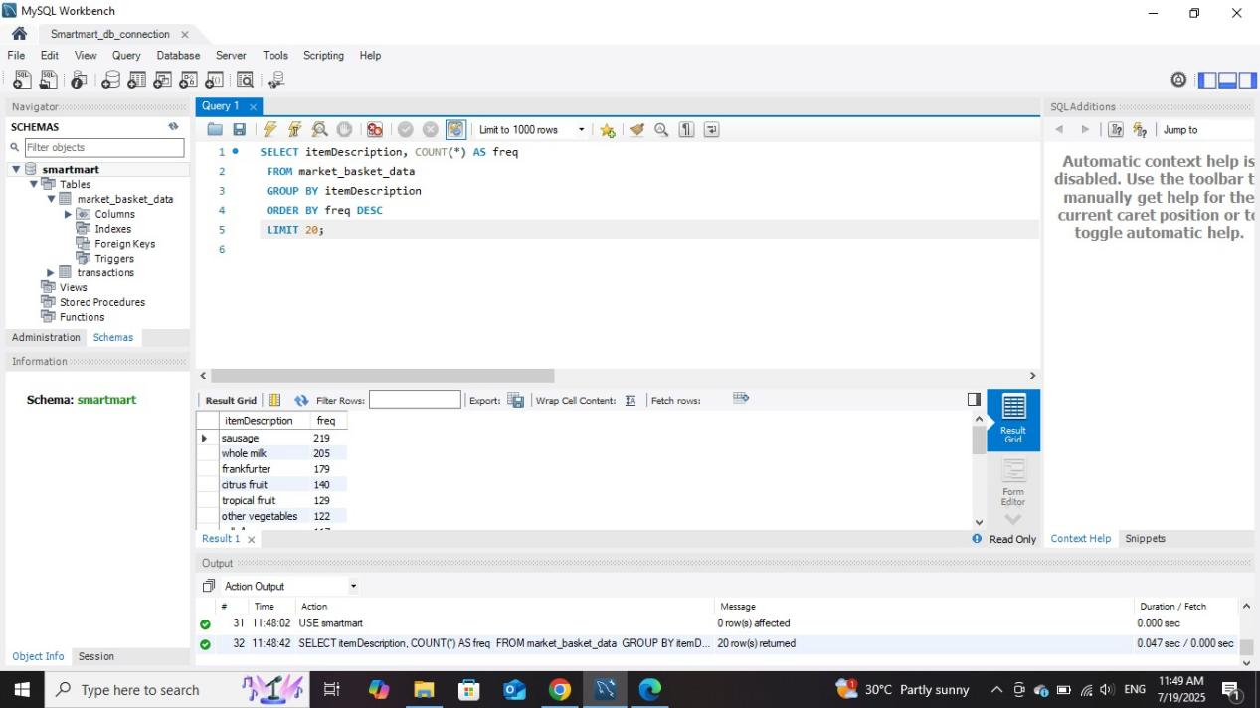

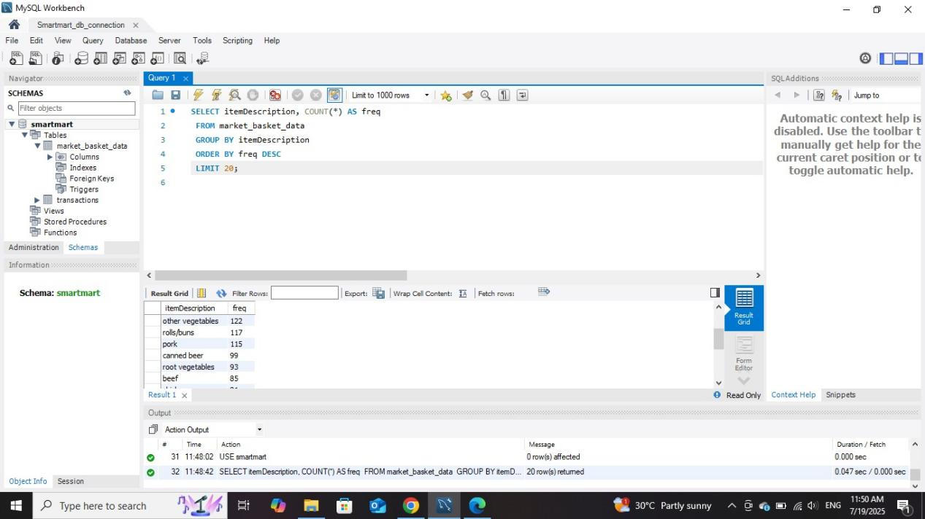

1. USE sales;

SELECT COUNT(*) AS total_transactions

FROM market_basket_data;

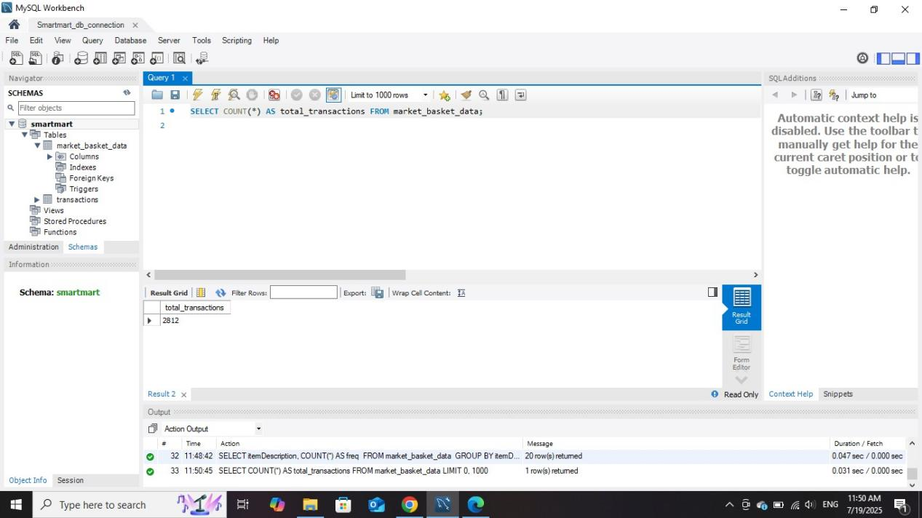

1. SELECT itemDescription, COUNT(*) AS freq, ROUND(COUNT(*) * 100 / (SELECT COUNT(*) FROM market_basket_data), 2) AS percentage_of_sales

FROM market_basket_data

GROUP BY itemDescription

ORDER BY freq DESC LIMIT 20;

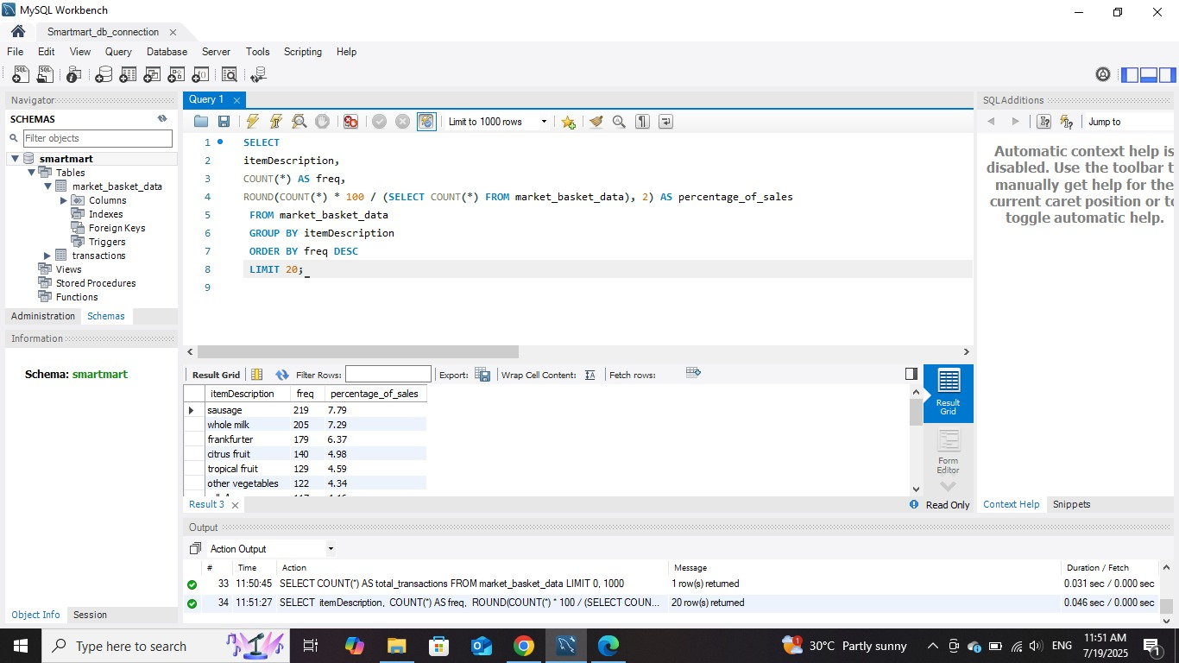

1. SELECT

day_of_week,

itemDescription,

COUNT(*) AS freq

FROM market_basket_data

GROUP BY day_of_week, itemDescription

ORDER BY day_of_week ASC, freq DESC;



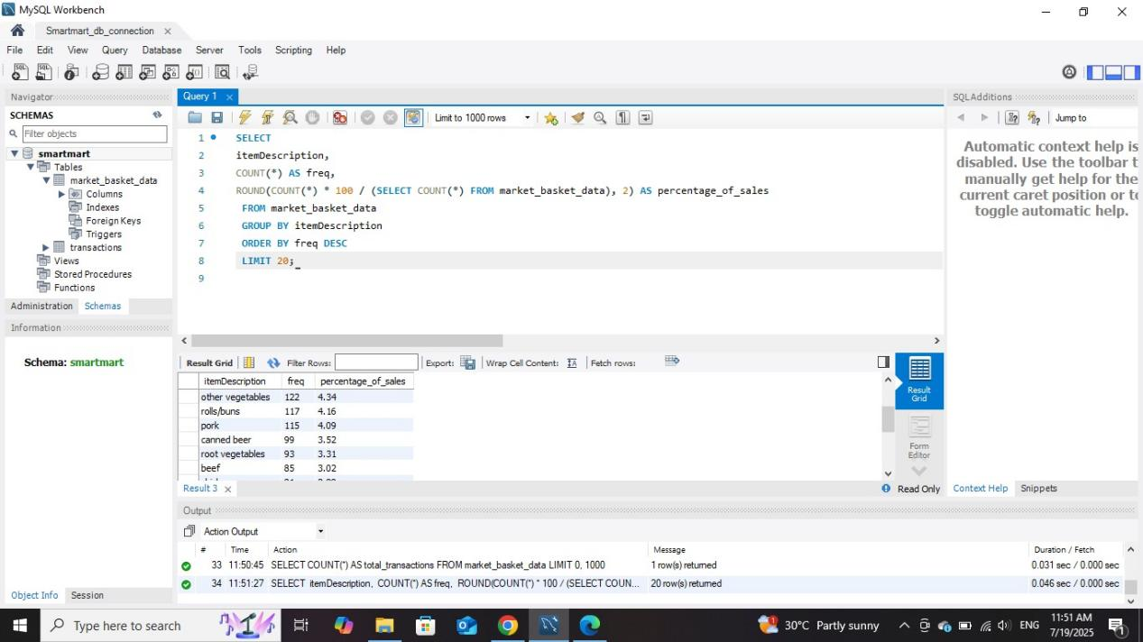

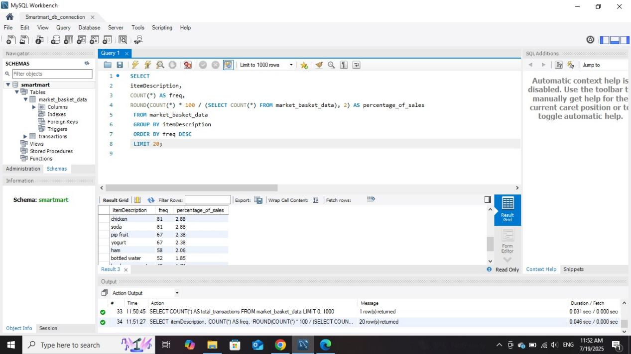

1. SELECT day_of_week, COUNT(*) AS transactions_count

FROM market_basket_data

GROUP BY day_of_week

ORDER BY day_of_week;  
  
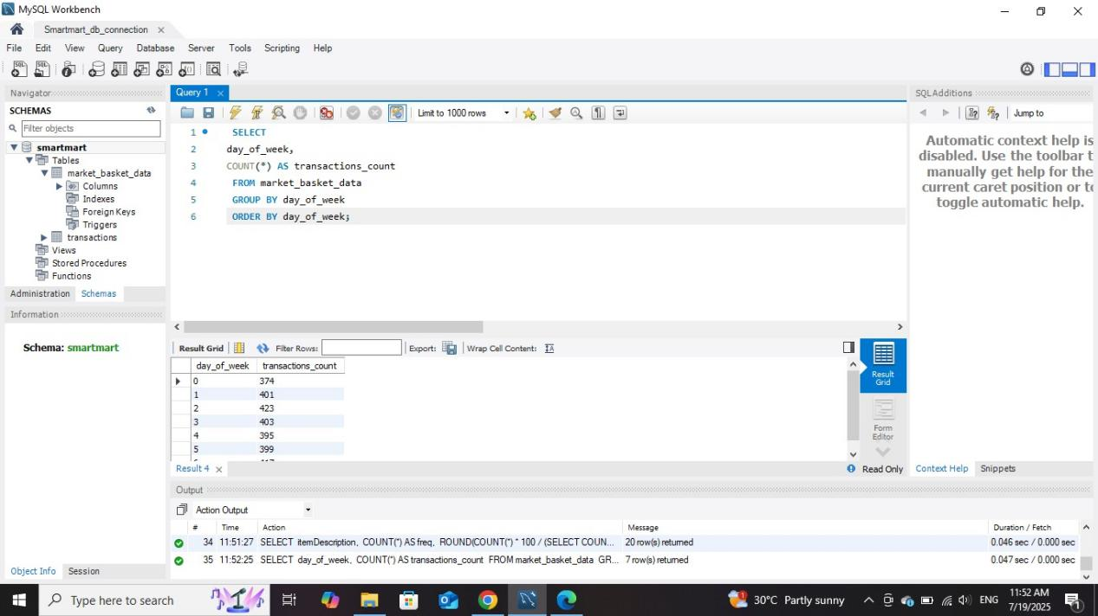

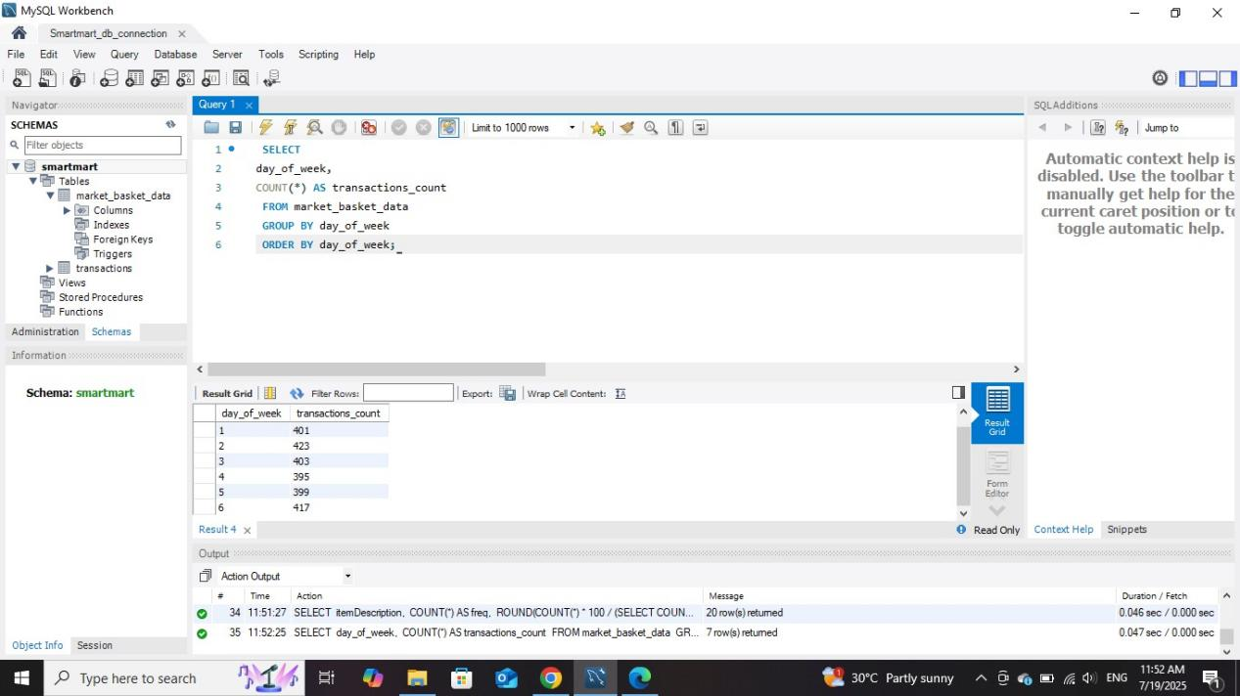

1. SELECT

day_of_week,

itemDescription,

COUNT(*) AS freq

FROM market_basket_data

GROUP BY day_of_week, itemDescription

ORDER BY day_of_week ASC, freq DESC;

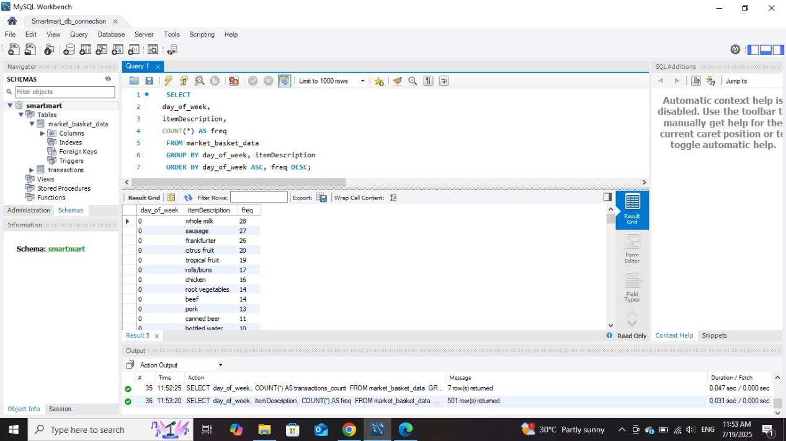

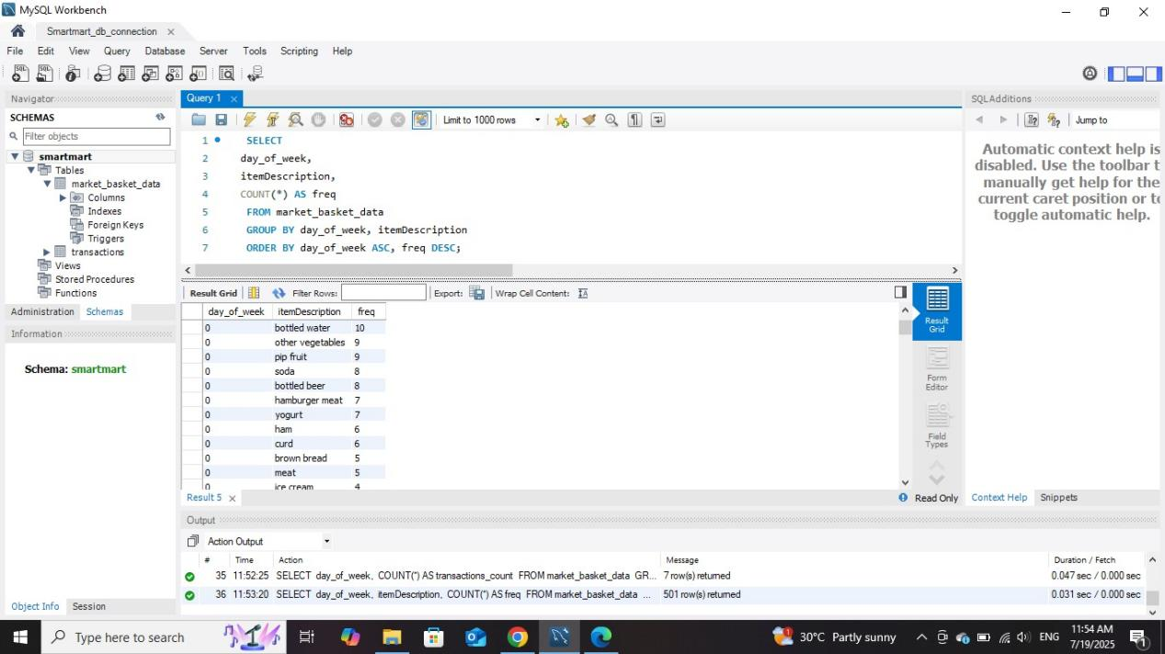

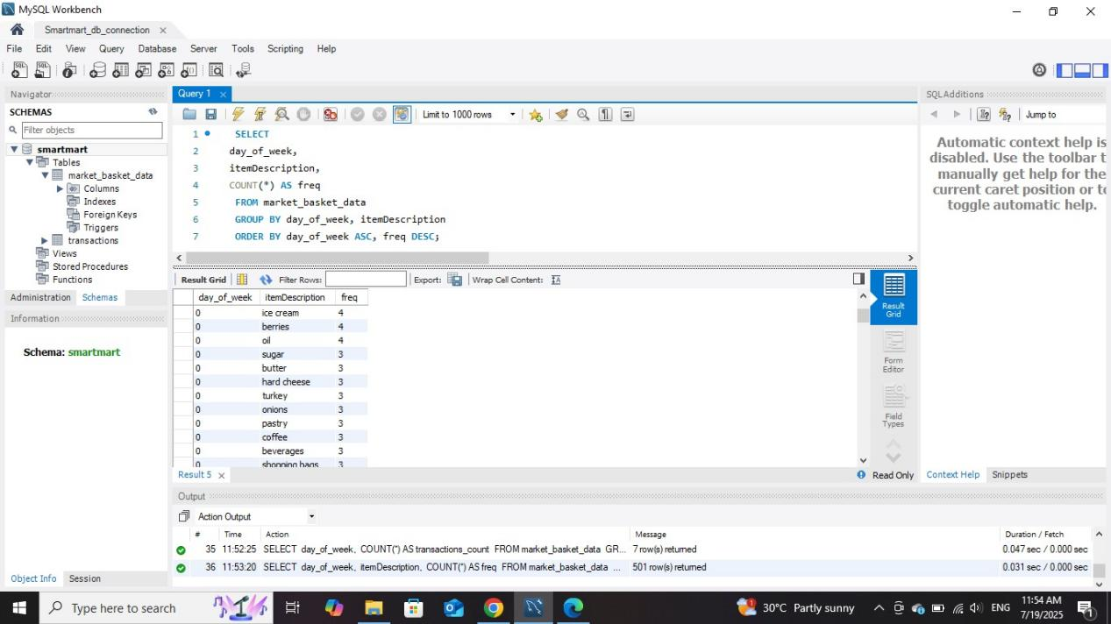

1. SELECT month, COUNT(*) AS transactions_count

FROM market_basket_data

GROUP BY month

ORDER BY month;

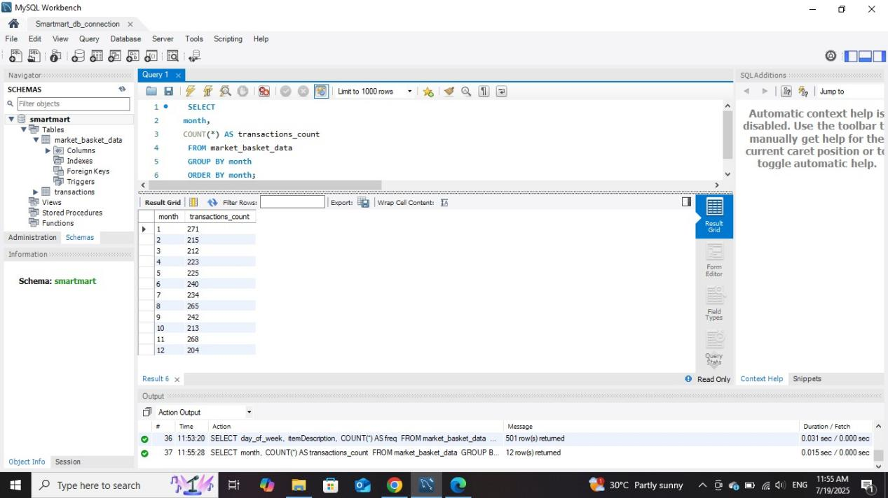

‘

1. SELECT

AVG(item_count) AS avg_basket_size

FROM ( SELECT

Member_number,

Date, COUNT(*) AS item_count

FROM market_basket_data

GROUP BY Member_number, Date) AS basket_sizes;  
  
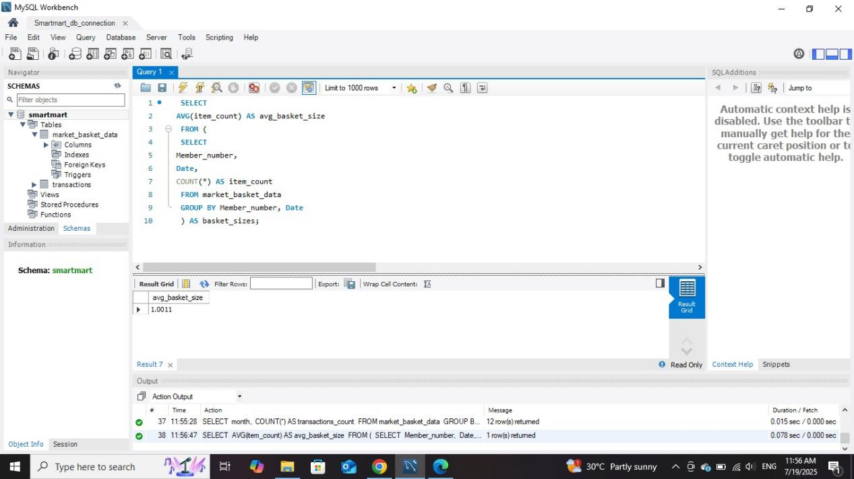

1. SELECT

a.itemDescription AS item1,

b.itemDescription AS item2,

COUNT(*) AS freq

FROM market_basket_data a

JOIN market_basket_data b

ON a.Member_number = b.Member_number

AND a.Date = b.Date AND a.itemDescription < b.itemDescription

GROUP BY item1, item2

ORDER BY freq DESC

LIMIT 20;

